Chapter 4: APPROXIMATION THEORY
4.1 The Approximation Problem

In our discussions of filter design, we have started with a given transfer function, H(s) for continuous-time filters, and H(z) for sampled-date ones. In general, however, the filter specifications do not include the transfer function, but only a set of numbers or graphs representing the desired gain, or phase or transient response. These data originate from the performance requirements of the system that the filter will be a part of. It is then the task of the circuit designer to find the transfer function which meets these specifications, and which is realizable in the available technology. Realizability for lumped linear circuits includes having rational transfer functions with real coefficients, and stability which requires that all poles of H(s) be located in the closed left half of the s-plane, or in the closed unit circle in the z-plane for H(z). Also, the order of the numerator must be at most equal to that of the denominator.

In different applications, different types of transfer functions should be used. For example, in telephony the gain response is more important than the phase, since the hearing is apparently tolerant of phase errors, while in video applications the phase may be critical. As shown in the following detailed discussions, a filter with a highly selective gain response tends to have a poor (i.e., nonlinear) phase response, and vice versa, a filter with linear phase has a poor (i.e., rounded) gain response.

Next, we are going to discuss gain-oriented filters. The frequency response of these filters has one or more frequency ranges called passbands, where input signal is passed on to the filter output essentially unchanged, and the ranges called stopbands, in which the signal is suppressed. The most common form is the lowpass filter, where ideally the gain |H(jω)| is constant between ω = 0 and ω = ω_{p} , and |H(jω)| << 1 for ω > ω_{s} . The frequencies ω_{p} and ω_{s} are the passband and stopband limit frequencies, respectively. If the stopband occurs at low frequencies and the passband at high frequencies, the circuit is a highpass filter, and the passband is centered at a finite nonzero frequency, it is a bandpass filter.

The analysis of reactance two-ports, discussed in Sec. 2.6, is useful in the approximation process for analog filters, even for active ones. The forward transmission function H(s) and the characteristic function K(s) have clear physical meaning in reactance two-ports; they are related to the signal power flow in the two-port. Also, in the design of these circuits, the two-port matrices can be calculated from these functions [TL]. For active circuits, these relations are lost. Here, H(s) is usually the voltage gain of the filter, and K(s) is an undefined function. It is, however, a useful aid in the approximation process. To see why, recall the relation
1
|H(jω)|² = ----------------- (4.1)
|K(jω)|² + 1

from Sec. 2.6. At the zeros of K(jω), |H(jω)|² = 1, at the poles of K(jω), |H(jω)|² = 0. So, for a selective filter the zeros and poles of K(jω) should lie in the passband and stopband of the filter, respectively. In the complex s-plane, both zeros and poles should be located on the jω-axis. Thus, the design of K(s) is a one-dimensional problem. By contrast, the poles of H(s) must lie inside the left half of the s-plane, and hence their direct calculation is complicated. Hence, an efficient solution of the approximation problem for gain-oriented filters is performed in the following steps: 1. Find |K(jω)|² for the chosen filter type; 2. Find |H(jω)|² from eq. (4.1); 3. Find H(s) from |H(jω)|². This process will now be carried out for a number of filter types.

4.2 The Butterworth Filter

From the discussions on the previous section, it follows that |K(jω)|² = K(jω). K(-jω) is a real rational function of ω² . For an n^{th}-order filter, the simplest choice is |K(jω)|² =C_{n} ω^{2n} . Following the steps outlined above, we obtain

1
|H(jω)|² = --------- (4.2)
C_{n}ω^{2n} + 1

The zeros of H(s) therefore lie at infinity, while its poles satisfy s_{k}^{2n} = -1. This equation has 2n solutions of the form
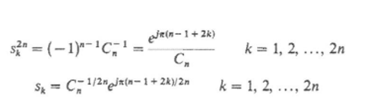
(4.3)

The s_{k} lie on a circle of radius C_{n}^{-1/2n}. As eq. 4.2 shows, the frequency where |H(jω)|² = ½ , which is the 3-dB frequency of the filter, is ω₃ = C_{n}^{-1/2n}. Thus, the magnitude of all s_{k} is ω₃ . The s_{k} are separated on the circle by equal angles π/n (Figure 4.1). For a stable filter, the s_{k} in the left half plane must be used as the poles of H(s).

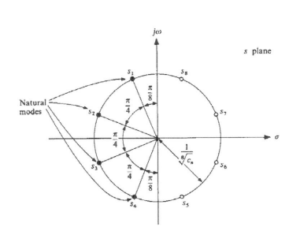

Figure 4.1 Natural frequencies of a fourth-order Butterworth filter.

This solution to the approximation problem of a low-pass filter is called the Butterworth response [BW]. An interesting property of the Butterworth function is that all derivatives of the gain H(jω)| with respect to ω are equal to zero at ω = 0, up to the (2n – 1)^{th}. Hence, it is sometimes called the maximally flat approximation.

Extensive software exists for the computer-aided design of filters [MW]. Figure 4.2 shows the computed results for a fifth-order Butterworth filter with a 20 kHz 3-dB frequency. The plots show the location of the natural frequencies, as well as the gain, phase, group delay and step responses.

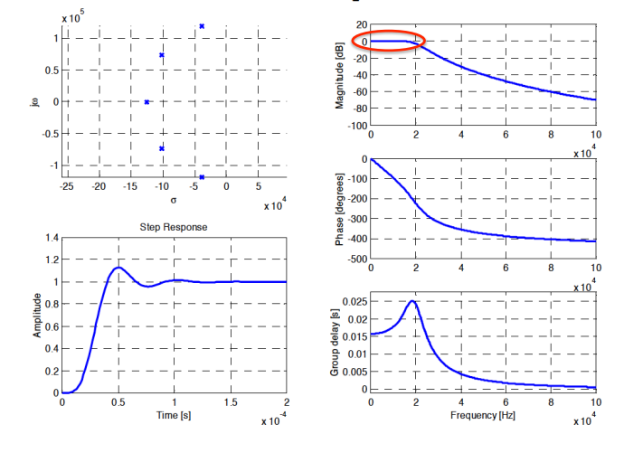
Figure 4.2 The computed responses of a fifth-order Butterworth filter.

4.3 The Chebyshev Type 1 Filter

The Butterworth filter has a gradual cutoff, which does not provide great selectivity. A sharper gain response can be obtained with an equal-ripple gain response in the passband. Such response can be obtained with a Chebyshev Type 1 filter. It uses

|K(jω)|² = k_{p}² cos² {n.cos⁻¹(ω/ω_{p})} (4.4)

Here, ω_{p} is the passband edge (limit) frequency, and k_{p} determines the passband ripple. The gain variation in the passband is 10 log (k_{p}² + 1) dB.

Analysis of the expression (4.4) shows the following [TL]. In spite of the irrational functions involved, |K(jω)|² is a polynomial in (ω/ω_{p}) ², named a Chebyshev polynomial after the 19th century Russian mathematician who invented it. For ω < ω_{p} , cos⁻¹(ω/ω_{p}) is real, and |K(jω)|² oscillates between 0 and k_{p}². For ω > ω_{p} , cos⁻¹(ω/ω_{p}) is imaginary, and |K(jω)|² is a monotone increasing function of ω/ω_{p} .

Both the Butterworth and Chebyshev filters have transfer functions whose numerator is constant, and denominator is a polynomial. Then all transmission zeros are at infinity. It can easily be shown that among all such “polynomial” filters, for given n, ω_{p} and k_{p} , the Chebyshev filter has the steepest cutoff for ω > ω_{p} . It is much more selective than the Butterworth filter.

Analysis shows that the natural modes of the Chebyshev filter lie on an ellipse, whose main axes are
Here,
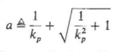
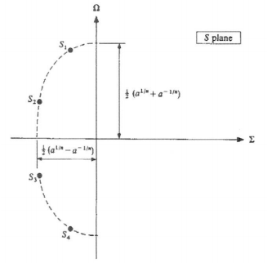
Figure 4.3 The natural modes of a fourth-order Chebyshev Type 1 filter.

Figure 4.4 shows the computed results for a fifth-order Chebyshev Type 1 filter with a 20 kHz passband edge frequency. The plots show the location of the natural frequencies, as well as the gain, phase, group delay and step responses. Compared to the Butterworth filter, the gain response is more selective, but the natural modes moved closer to the jω-axis, causing increased distortion in all other responses.
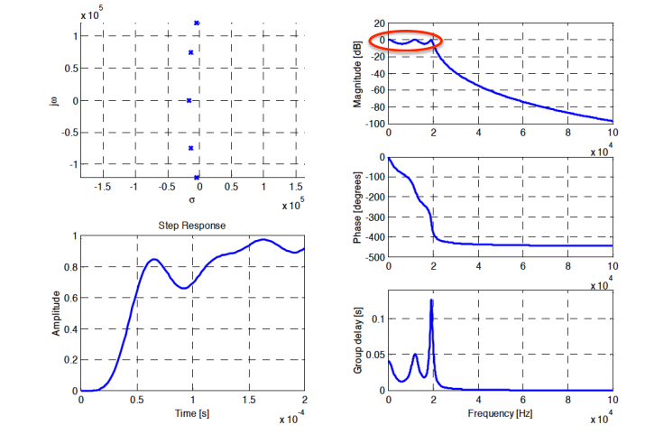

Figure 4.4 The computed responses of a fifth-order Chebyshev 1 filter.

4.4 The Chebyshev Type 2 Filter

The Chebyshev Type 1 filter is characterized by its equal-ripple passband. Another low-pass filter, with equal-ripple behavior in its stopband, may be obtained by transforming the |K(jω)|² expression in eq. (4.4) in two steps:

- Replace ω/ω_{p} by ω_{p}/ω;
- Replace |K(jω)|by 1/|K(jω)|.

The resulting transfer function H(s) will have zeros in the stopband at the frequencies ω_{p}² /ω_{i} , where the ω_{i} are the peak gain frequencies of the Chebyshev Type 1 filter. The stopband gain will oscillate between 0 and 10 log (k_{p}⁻⁻² + 1) dB.

Figure 4.5 shows the computed results for a fifth-order Chebyshev Type 2 filter with a 20 kHz passband edge frequency. Since the gain is maximally flat at ω = 0, the phase, delay and transient responses are somewhat similar to that of the Butterworth filter.
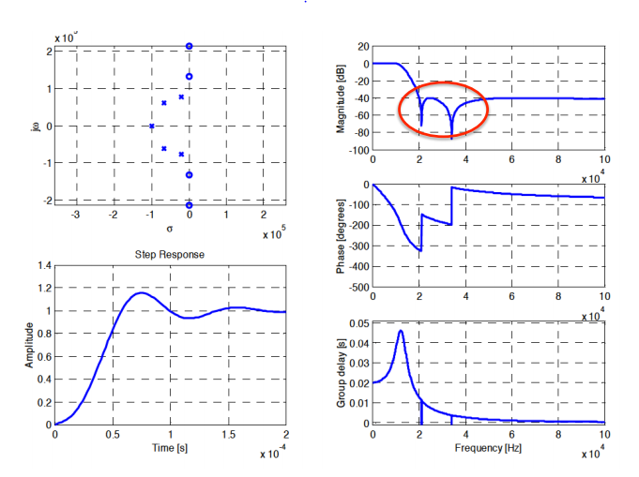

Figure 4.5 The computed responses of a fifth-order Chebyshev 1 filter.

4.5 The Elliptic Filter

Introducing equal-ripple behavior in passband or stopband improves the selectivity of the filter. Introducing equal-ripple response in both results in the highest possible selectivity for prescribed order and passband and gain parameters. The characteristic function K(s) for these filters can be written in terms of elliptic functions, and they are named elliptic filters. Figure 4.6 shows the computed results for a fifth-order elliptic filter with a 20 kHz passband edge frequency. The excellent gain response is balanced by badly distorted phase, delay and step responses.

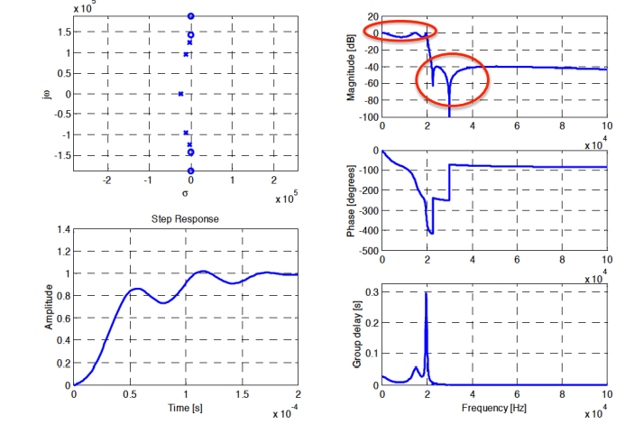
Figure 4.5 The computed responses of a fifth-order elliptic filter.

4.6 The Bessel-Thomson Filter

The role of the filters discussed so far in Chapter 4 was to discriminate between signals in their passbands and those in their stopbands. Little attention was paid to their phase and time responses. However, in many applications, such as video and data transmission, the time response is of greater importance. Ideally, if the input signal to the filter is f(t), we would like the output g(t) to be an undistorted replica of f(t). It is often permissible to include a scale factor k and a constant delay between the signals, so that g(t) = k.f(t – T) may be an acceptable output. Since the filter needs to modify the spectrum of f(t), neither k nor T can be exactly constant. As the computed responses of the gain filters shown above demonstrate, the fidelity of the time response is more dependent on the phase and delay response than the on the gain. Hence, in an important class of filters, the goal is to get an accurate approximation to a linear phase, or equivalently to a constant delay. The approximation can conveniently be carried out in terms of the group delay, T_{g}(ω) = - dØ(ω)/dω. Here, Ø(ω) is the phase shift between the input and output signals at frequency ω. The error in T_{g} is sensitive indication of the nonlinearity of the phase response. Also, for s = jω, T_{g}(s) is a rational function of s, which makes the approximation process relatively easy. Requiring that T_{g}(ω) approximate a constant value 1 in a maximally flat manner leads to the solution for the transfer function

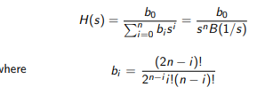 (4.5)

The function B(x) is a Bessel function. The solution to the maximally flat group delay problem was found by W. E. Thomson [Th], and hence the filter is called the Bessel-Thomson filter.
Figure 4.7 shows the computed results for a fifth-order Bessel-Thomson filter with a 20 kHz delay approximation range. The gain response is not very selective, but all other responses are nearly ideal, including the step response, which has a sort rise time and no undershoot or overshoot.

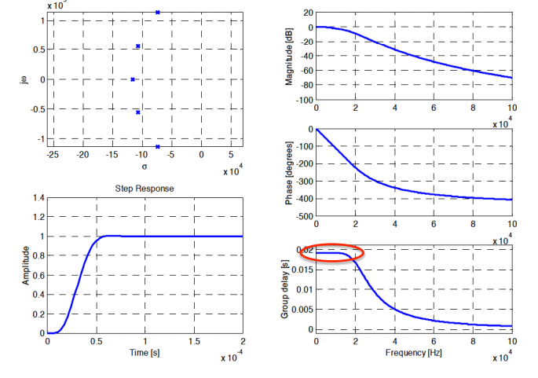
Figure 4.6. The computed responses of a fifth-order Bessel-Thomson filter.

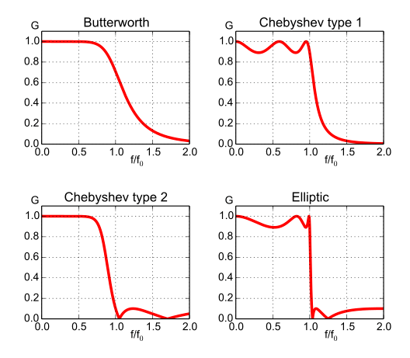

[TL] G. C. Temes and J.W. LaPatra, Introduction to Circuit Synthesis and Design, McGraw-Hill, 1977.

[BW] S. Butterworth, “On the Theory of Filter Amplifiers,” Wireless Engineer, vol. 7, 1930, pp. 536–541.

